

TRAINING MANUAL on stock module



[Date]

DFM FOODS LTD.

[Company address]

**ERPNext System**

* Login page of DFM Foods ERP Next system.

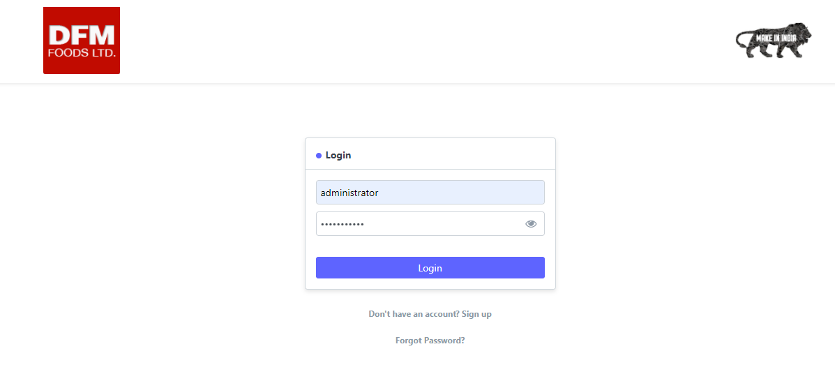

**Gate Entry Process in Stock Module**

* After logging in the ERPNext system below screen will appear for users. Purchase Department users can navigate to their system by clicking on “Stock” Module.

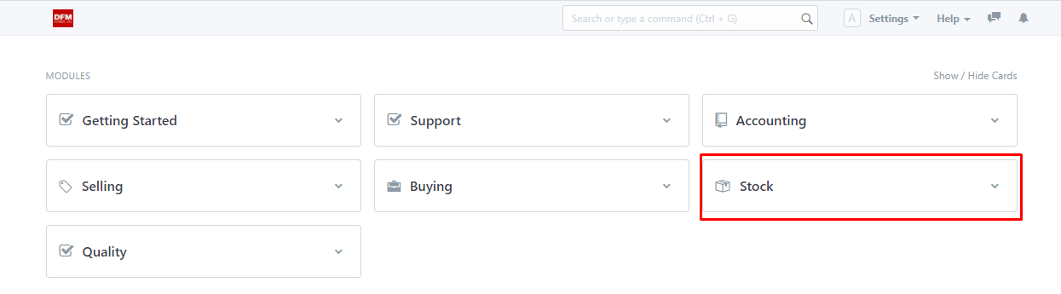

* On clicking “Stock” Module the following screen will appear. By clicking on “Gate Entry” user can enter the details when the vehicle arrives at the gate.

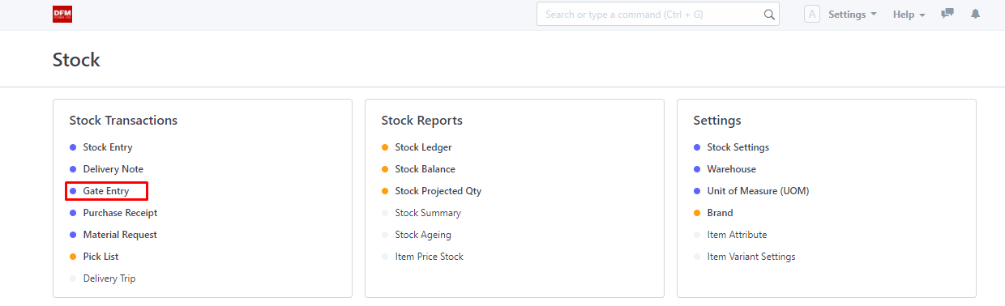

* On entering in gate entry screen user will click on “New” button.

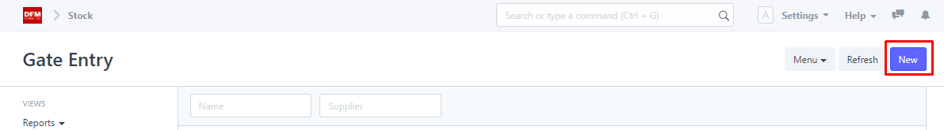

* After clicking on new button user will land on the screen and will select “Gate Entry Type” as “Inward”.

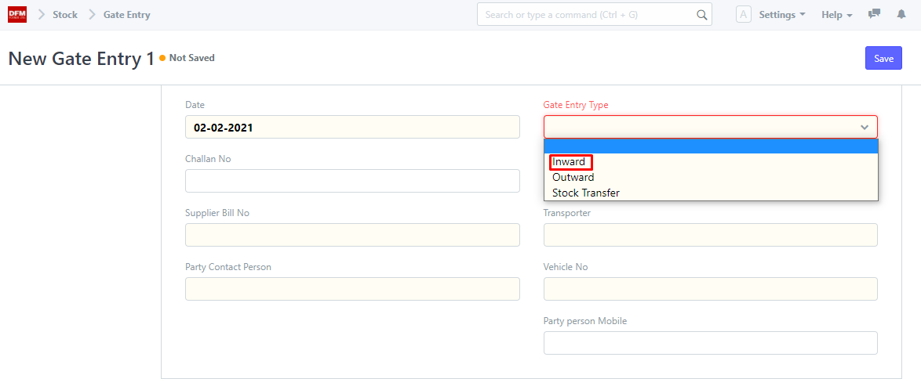

* User will fill all the details after selecting gate entry type and click on save.

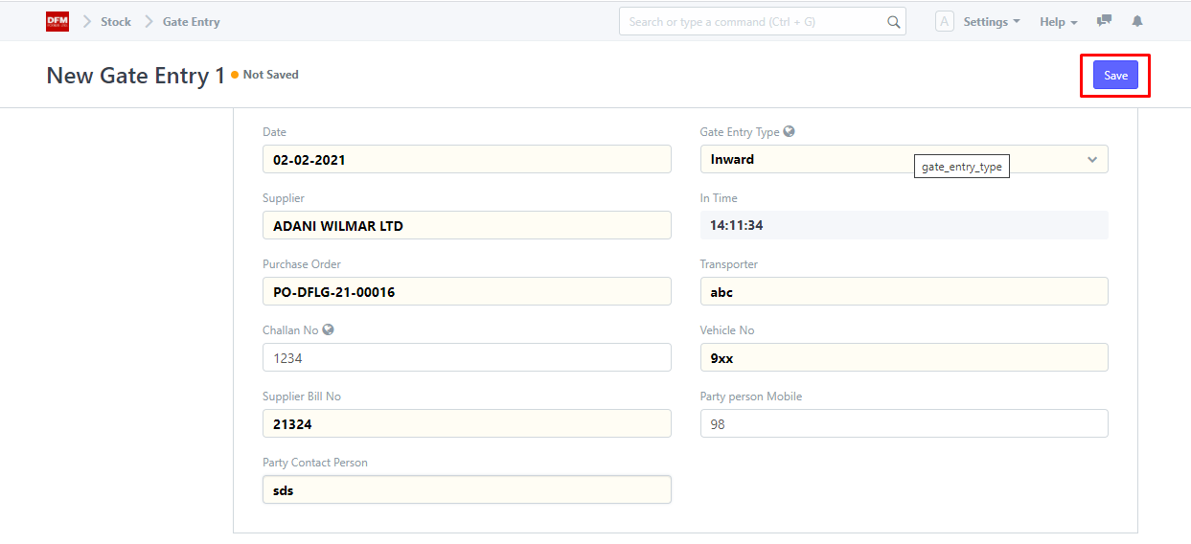

* After clicking on save the following screen will appear and user can see the gate number generated: **GE-00030.**

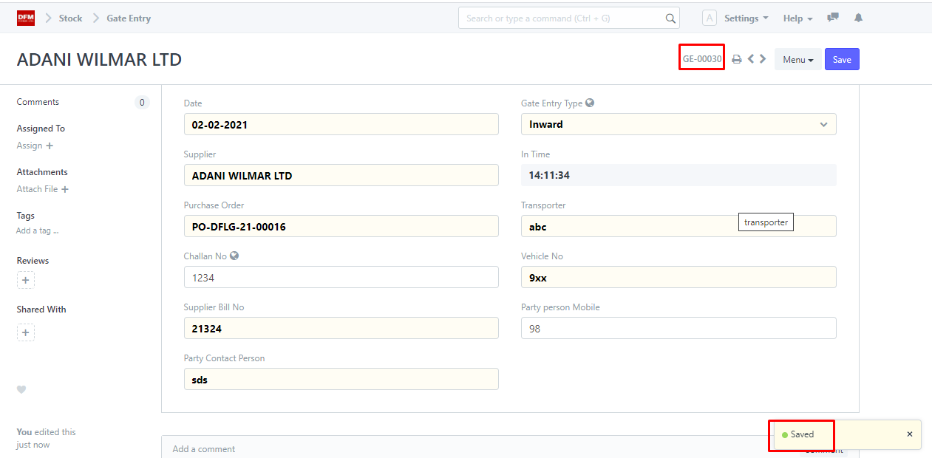

* User can see the gate entry in “Gate Entry Screen”.



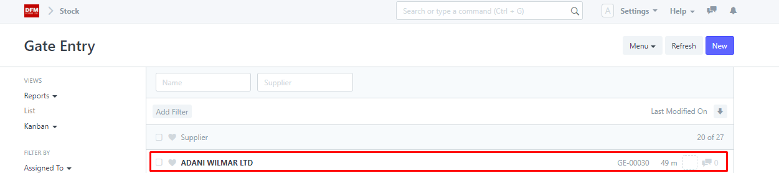

**Purchase Receipt in Stock Module**

* User can record “Purchase Receipt” by following process.

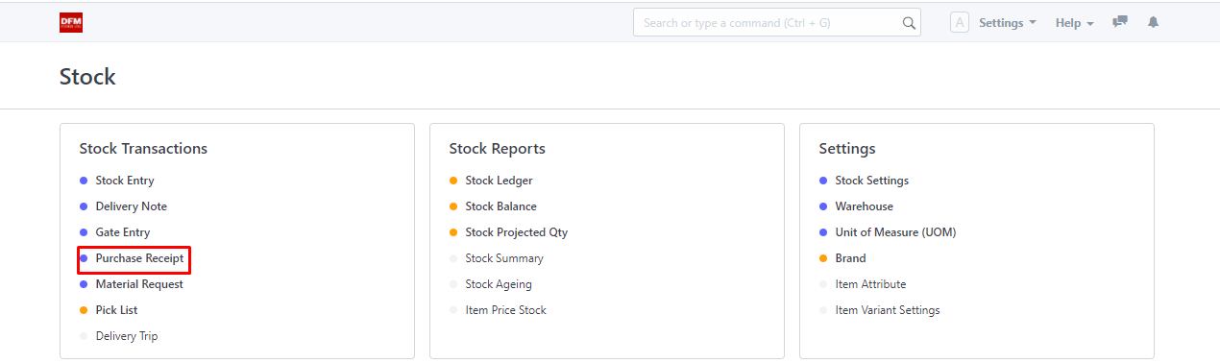

* User will click on “New” to create a purchase receipt.

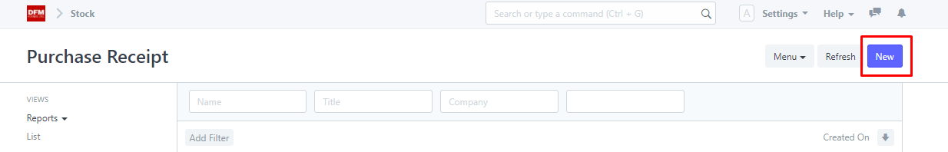

* User have to add company name and supplier name and then click on “Get Items from”.

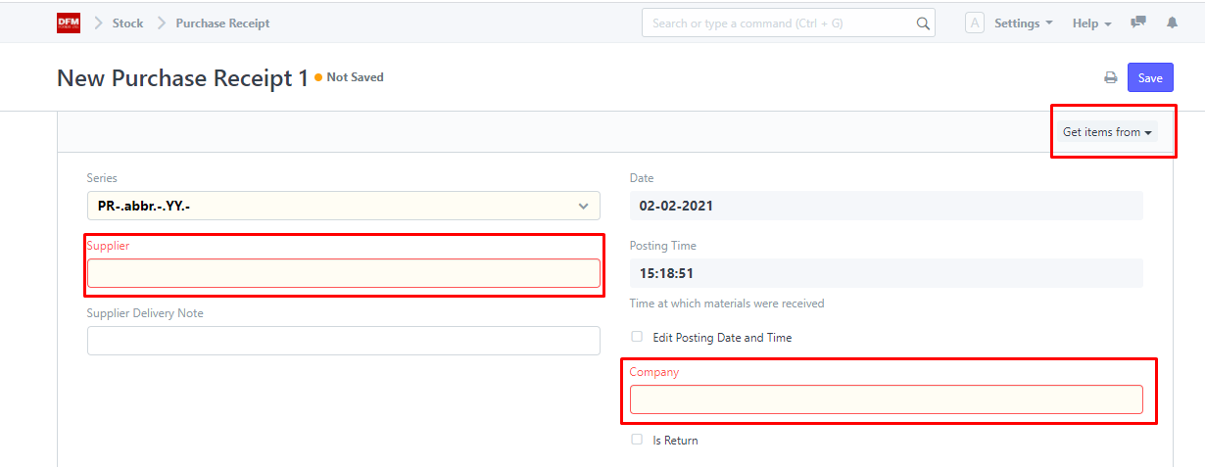

* Click on “Purchase Order”.

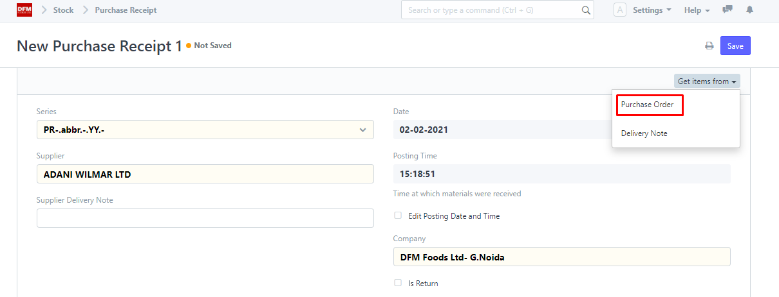

* User will select the relevant PO and click on “Get Item”.

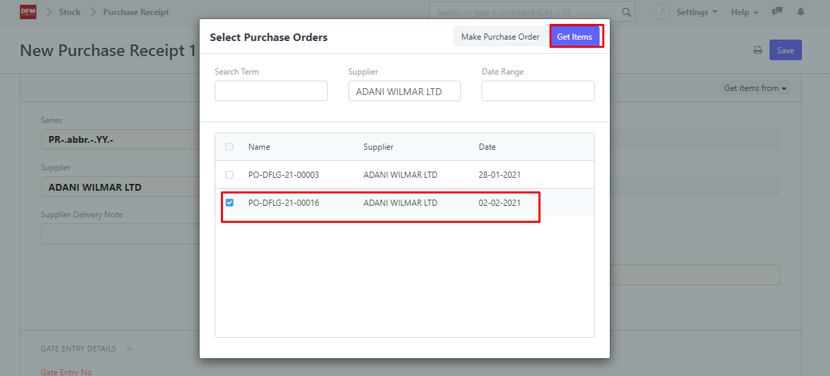

* User will enter Gate entry number wherein all the details will be auto-populated.

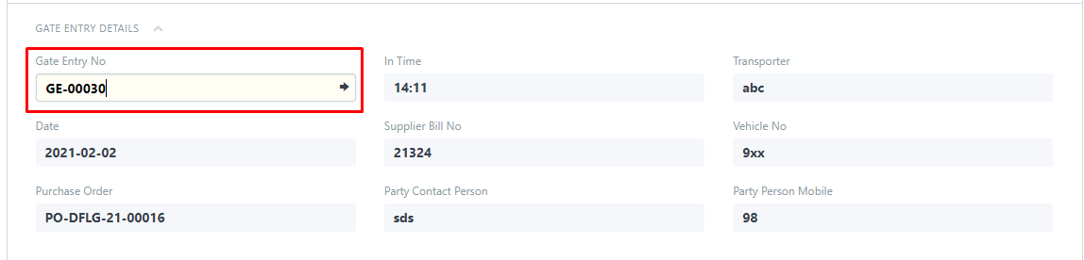

* In items section, User will have the option to:
* Enter Inv Qty.
* Enter Rate(sup)
* Enter Rcvd Qty
* User will automatically see the difference between invoice quantity and received quantity i.e “Short Quantity”. (1400-1200=200)

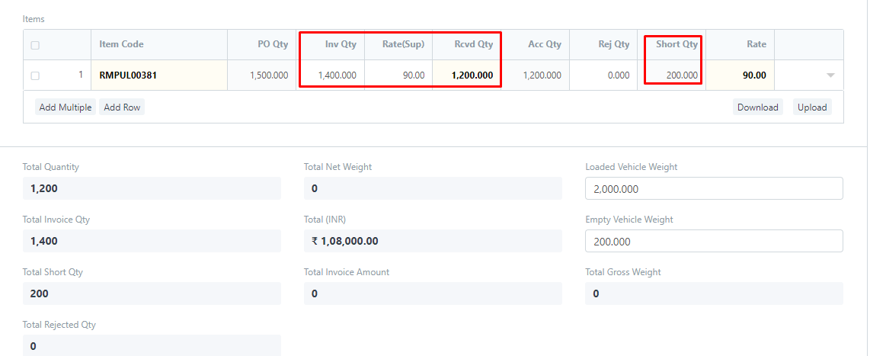

* After filling the above details user will click on “Save”.

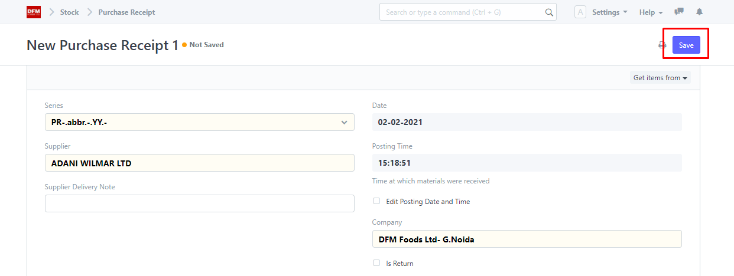

* When clicked on save following pop-up will appear.

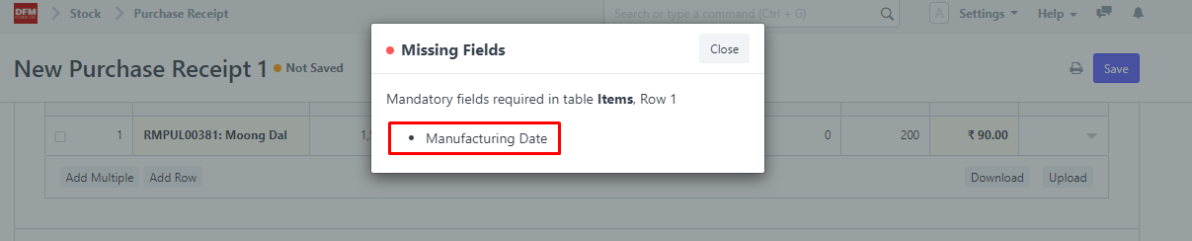

* User will enter manufacturing date in the given section.

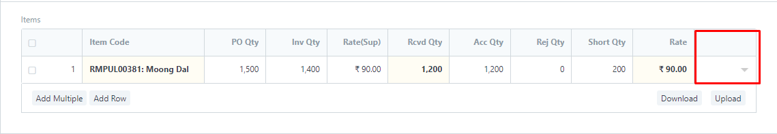

* User will enter manufacturing date and expire date will be auto-populated based on the shelf life of the item in masters. Now the user will save purchase receipt.

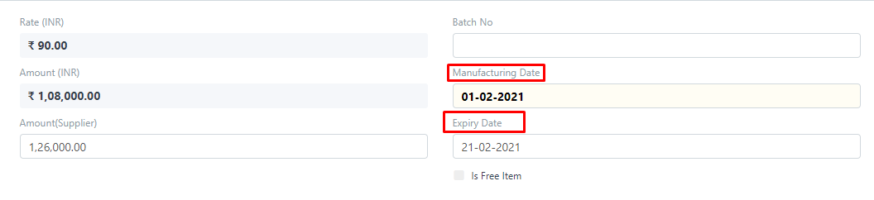

* Upon saving the following screen appears wherein the quality inspection number has been generated and the process goes to quality control department.

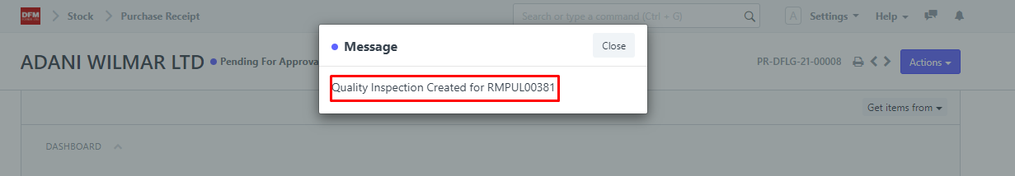

* User will click on Actions button and will approve the Request and status will change to pending for quality from pending for approval.

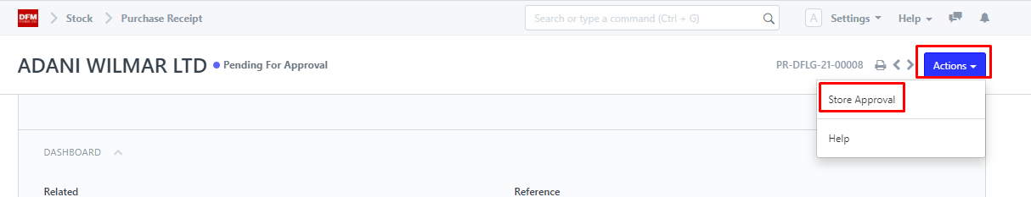

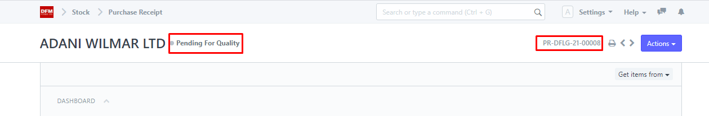

**Quality Inspection Process In Stock Module**

* Quality Department User will navigate to the purchase receipt pending for quality inspection through following process.

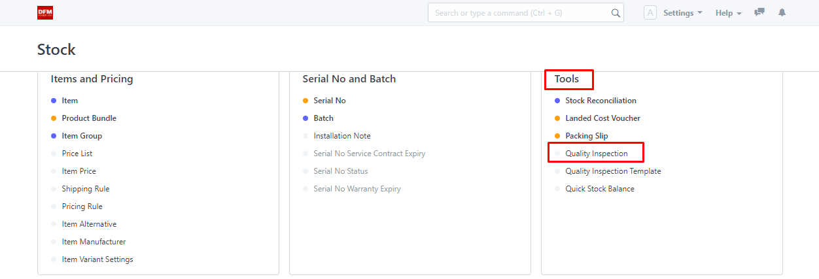

* User can see pending quality request in quality inspection screen.

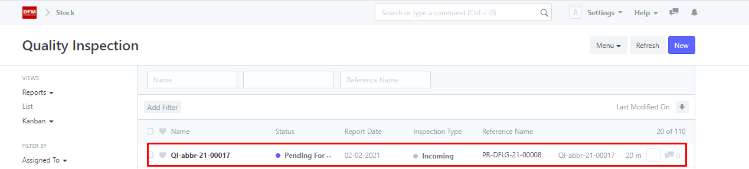

* User will enter the details based on the criteria pre-defined.

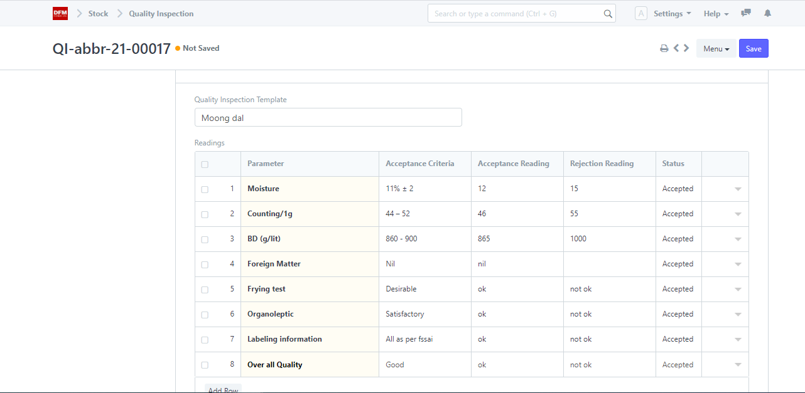

* Quality inspector will reject the quantity if not found satisfactory and can add remarks as required.

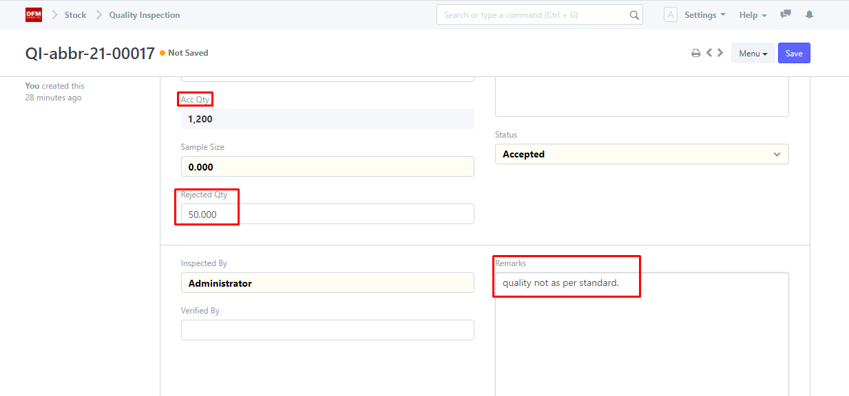

* User will click on Save button.

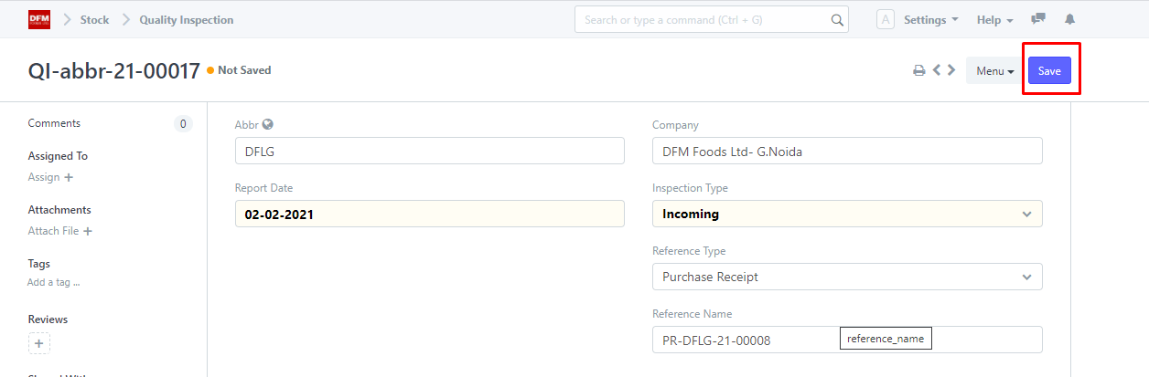

* When the document is saved status will change to pending for approval and user will click on actions button to approve the document.

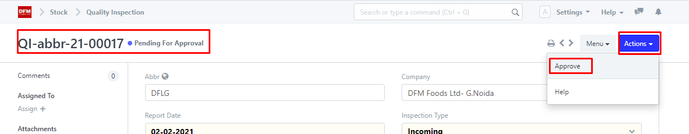

* The status will change to approved from pending for approval.

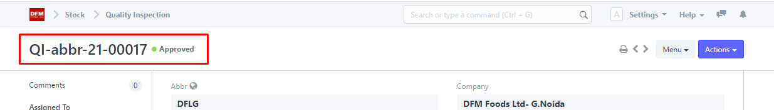

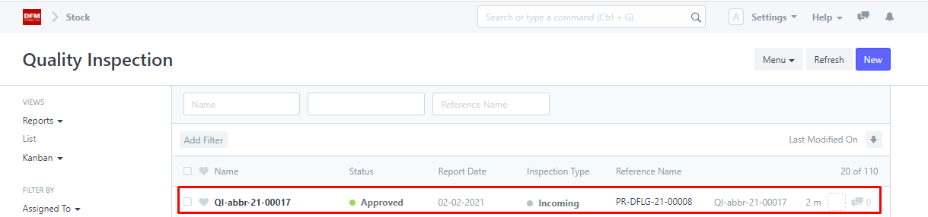

* When the quality request gets approved batch number is automatically generated.

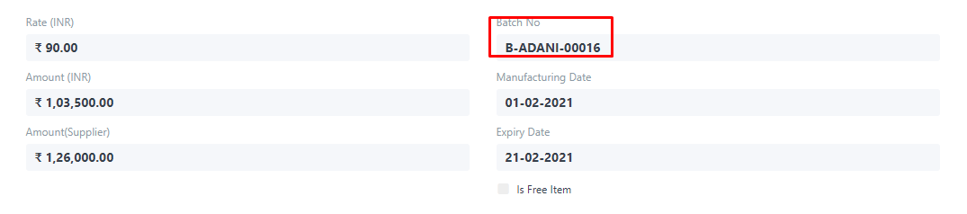

* Upon quality approval, stock would be affected in stores ledger.

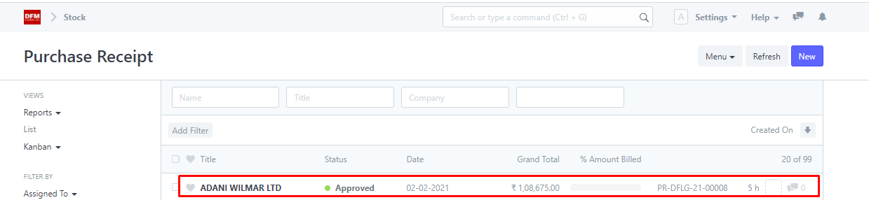

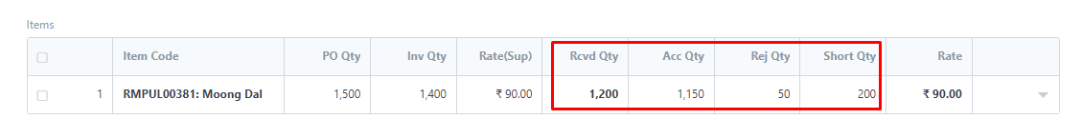

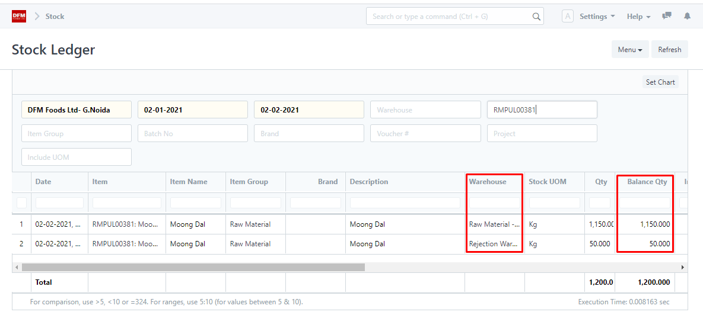

**Material Issue Process In Stock Module**

* User will navigate to material issue screen by following process:

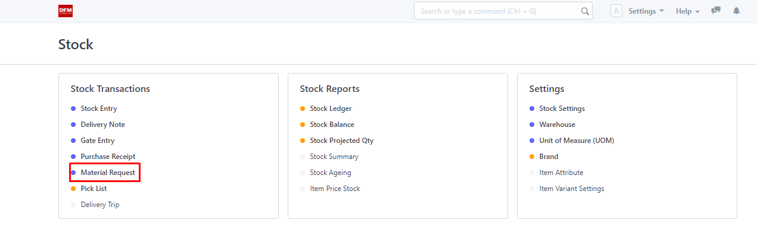

* User will click on “New“ button.

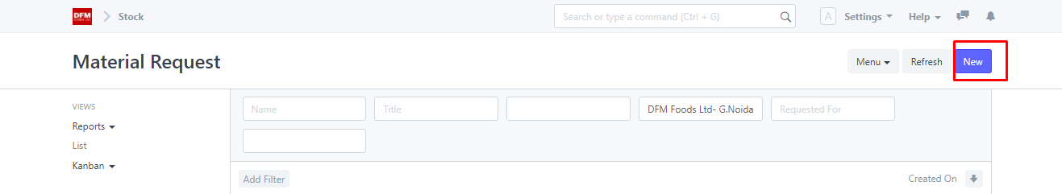

* User will select “Material issue” from dropdown.

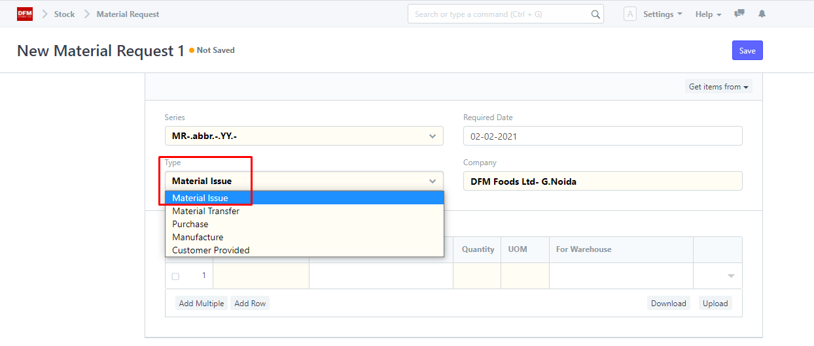

* Navigate back to stock and click on stock entry for material issue.

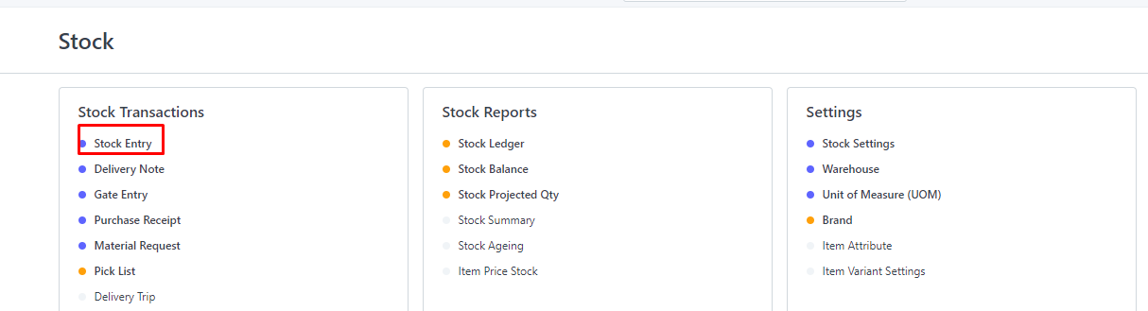

* User will click on new for material issue.

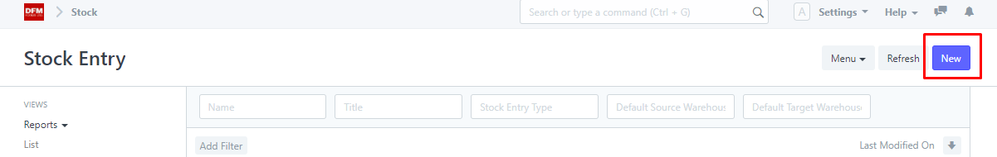

* User will select stock entry type as material issue.

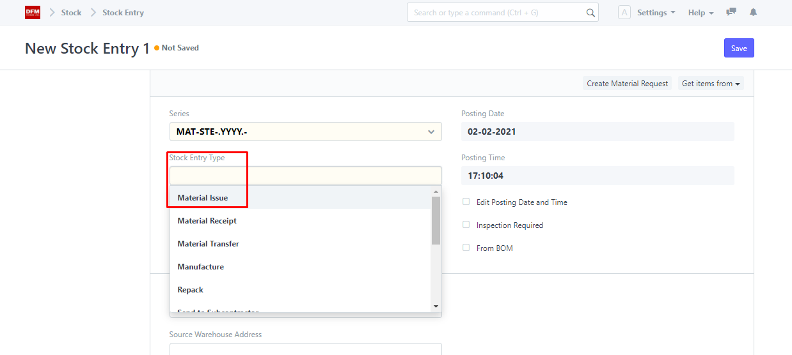

* User will click on “Get Item from” button and select material request.

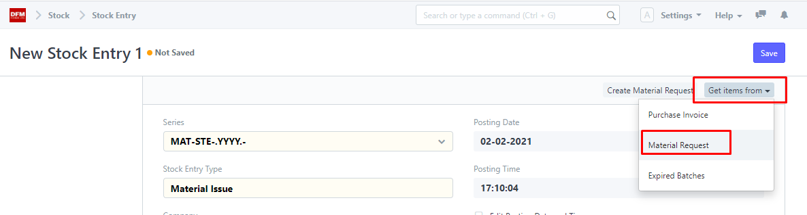

* Click on material request number and press get items button.

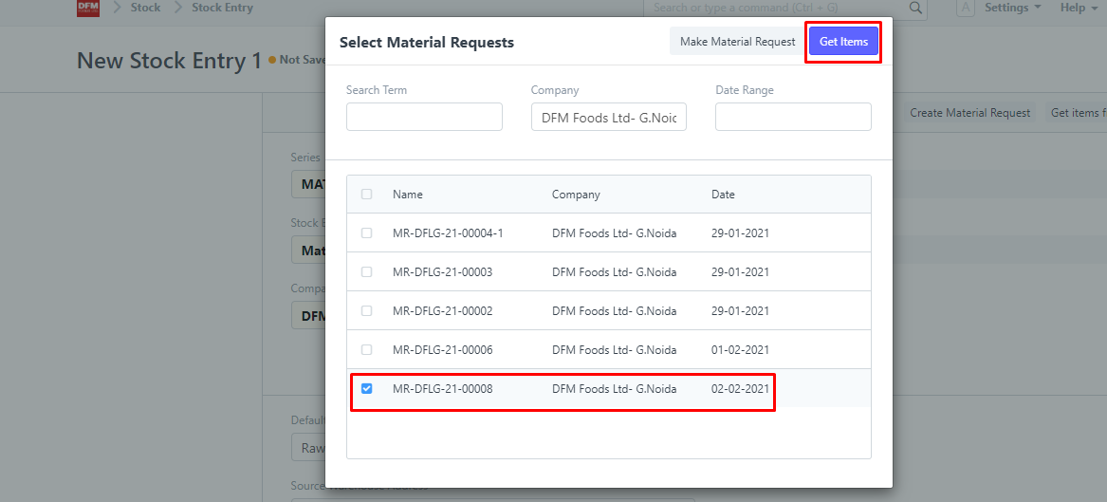

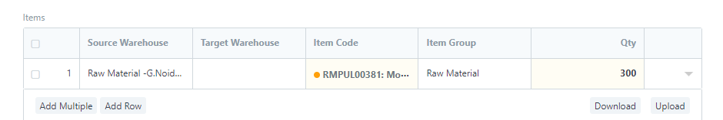

* User will click on save button.

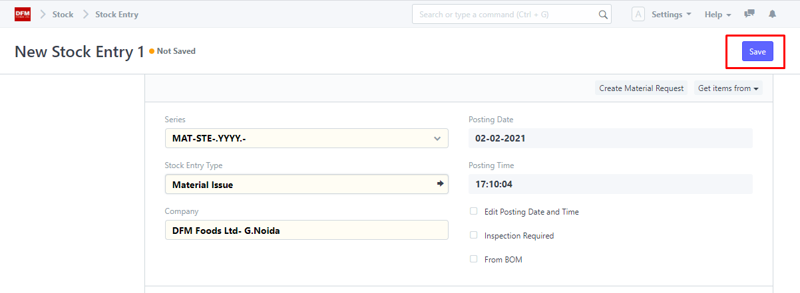

* On clicking save, below pop-up will appear.

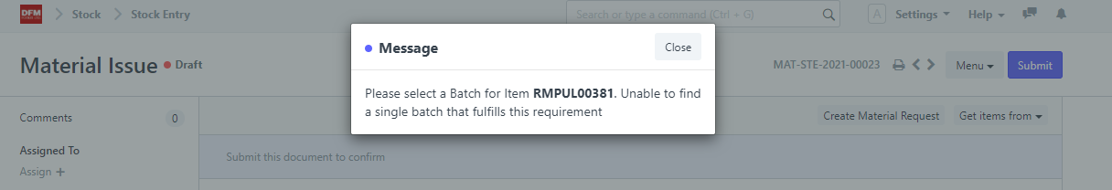

* User will enter the batch details from which the material is to be issued.

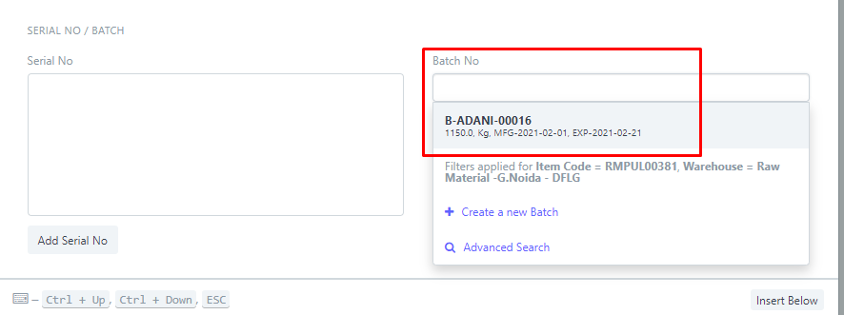

* After clicking on save, the user has to click on submit button.

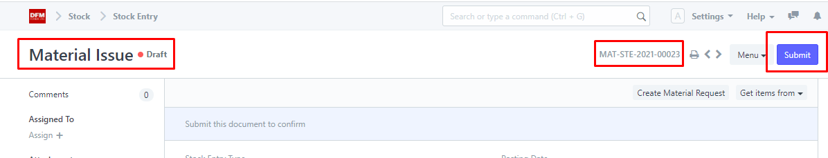

* Click on “Yes”.

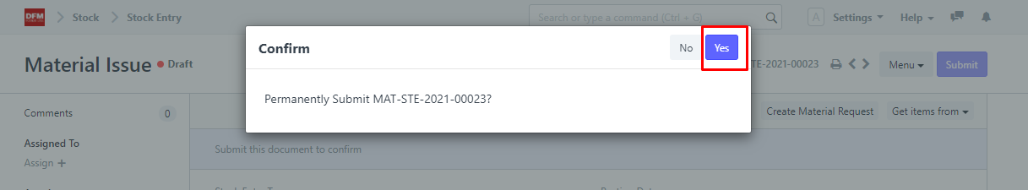

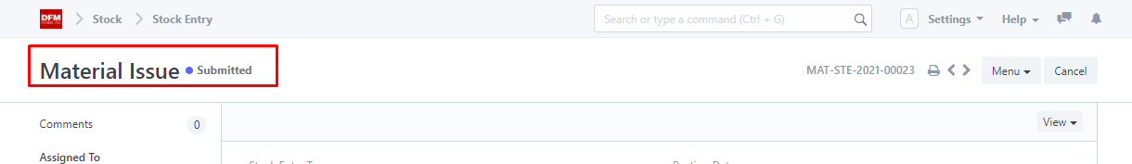

* User can see in material request that material request has been issued.

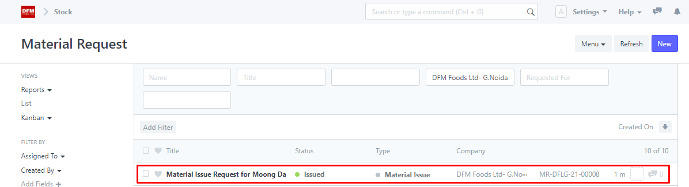

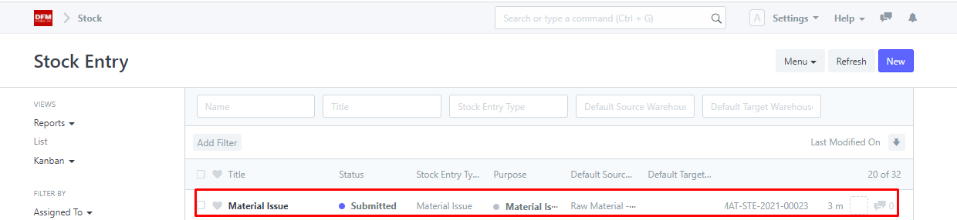

* User can see in stock ledger the movement in quantity of goods.

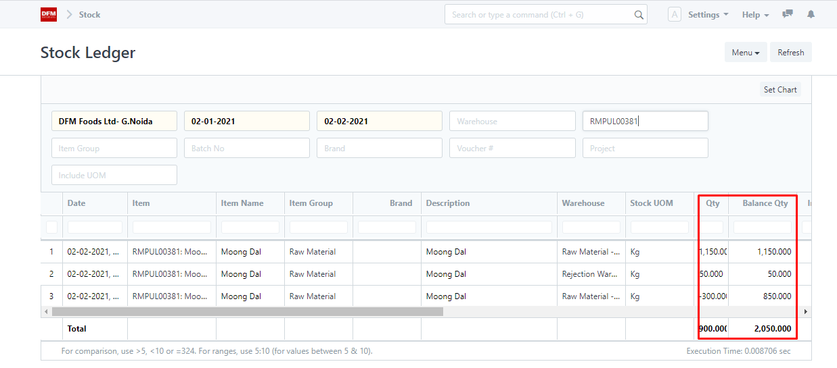

**Material Transfer Process In Stock Module**

* Navigate back to stock in material request.





* User will select material transfer request.

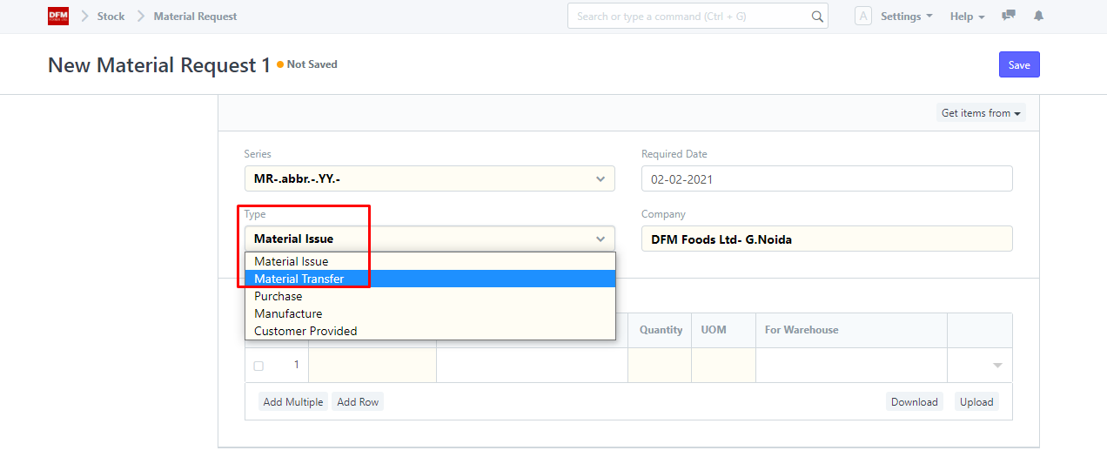

* User will fill “For Warehouse” field.

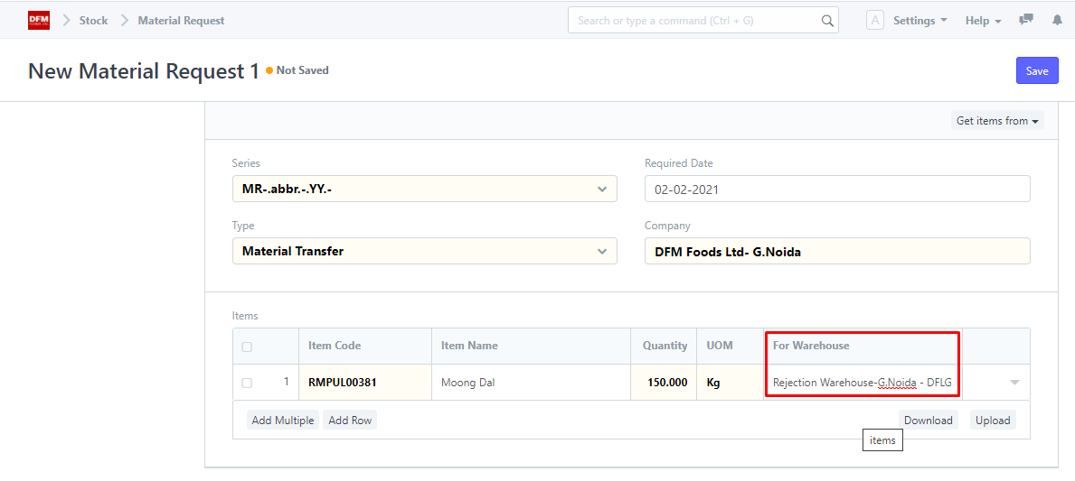

* On clicking save, user will have to click on submit button.

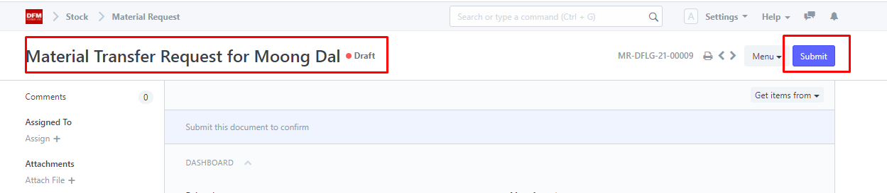

* On clicking submit, status will change to pending from draft.

